ADVENTURE WORKS · TECHNICAL SUPPORT

Chain Keeps Dropping Off the Chainring
Drivetrain Document TS-008 Rev. A
Applies to | All geared Adventure Works models
Difficulty | Intermediate
Time required | 20 – 40 minutes
Tools needed | Hex keys, Torque wrench, Chain checker

Symptoms
- The chain falls to the inside (toward the frame) when shifting to the small ring.
- The chain drops to the outside when shifting to the big ring.
- Chain drops over bumps even without shifting.
- A grinding sound as the chain rubs the frame after dropping.
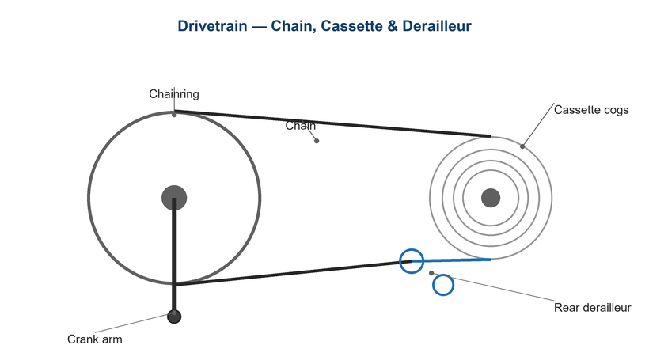
Figure 1. Front shifting and ring profile control whether the chain stays put.

Likely Causes
- Front derailleur limit screws set too wide.
- Front derailleur height or angle out of adjustment.
- A worn or stretched chain riding poorly on the rings.
- Worn chainring teeth (shark-fin profile).
- Missing or misadjusted chain catcher on 1x setups.
Safety first
- Stop pedaling immediately if the chain drops to avoid jamming it in the frame.
- Keep fingers clear of the chainring teeth.
- Support the bike so you can turn the cranks safely by hand.

Customer Fix — Step by Step
Suitable for home repair with basic tools. Work through the steps in order.
- Reproduce the drop and note the direction — inside drops mean the low limit is too loose; outside drops mean the high limit is too loose.
- For inside drops, turn the front derailleur 'L' limit screw clockwise a little to stop the cage swinging too far in.
- For outside drops, turn the 'H' limit screw clockwise a little to limit outward travel.
- Shift across the range and fine-tune so the chain reaches both rings without dropping.
- Check chain wear; replace a chain past its limit, as a worn chain drops more easily.
- On a 1x drivetrain, confirm the chain-catcher or clutch is functioning.

Technician Reference
Additional checks and adjustments for service technicians and advanced users.
- Set front derailleur height to 1–3 mm above the big-ring teeth and align the cage parallel to the rings.
- Re-set both limit screws precisely, then re-index the front shift.
- Inspect chainrings for worn or hooked teeth; replace worn rings.
- On 1x, verify the narrow-wide ring is in good condition and the rear derailleur clutch holds adequate tension.
- Fit or adjust a chain catcher just inboard of the small ring as insurance.

Torque & Specifications
Fastener / setting | Specification
FD height above big ring | 1 – 3 mm
FD clamp bolt | 5 – 7 N·m
Chainring bolts | 8 – 10 N·m
Chain catcher bolt | 2 – 3 N·m
Chain wear limit | 0.5 – 0.75%

Figure 2. Limit screws define how far the chain can travel in each direction.
Pro tips
- A quick win on 1x bikes is fitting a simple chain catcher.
- Avoid extreme cross-chaining (big-big / small-small) to reduce drops and wear.

When to Visit a Service Center
- Chainrings are visibly worn and need replacement.
- A 1x clutch derailleur no longer holds tension.
- The front derailleur mount or braze-on is damaged.
- Drops continue after correct limit and height setup.
This guide is provided for reference. Torque values are typical starting points — always follow the specific component manufacturer's instructions. © Adventure Works.

